REPORT
1. INTRODUCTION
1.1 Project Overview
Project Title: Civil Engineering Insight Studio
TeamID: LTVIP2026TMIDS43988
Team Leader : A Chandu
Team member : Agavinti Sathvik
Team member : A Dakshayani
Team member : Battala Roopa Sree
Project Description
Civil Engineering Insight Studio is a data-driven web application designed to assist civil engineers, students, and construction planners in analyzing, visualizing, and interpreting civil engineering project data. The system converts raw construction-related data such as material quantities, costs, soil properties, and project timelines into meaningful insights using analytical tools and visual dashboards.
The platform reduces manual effort, improves accuracy, and supports data-based decision-making in construction planning and infrastructure management.

1.2 Purpose of the Project
The purpose of Civil Engineering Insight Studio is to:
- Provide analytical insights for civil engineering data
- Reduce manual calculations and human errors
- Improve planning and cost estimation accuracy
- Support students in understanding real-world civil engineering analysis
- Enable data-driven decision-making in construction projects
2. IDEATION PHASE
2.1 Problem Identification
In traditional civil engineering practices, data analysis is often done manually using spreadsheets and paperwork. This approach is time-consuming, error-prone, and inefficient, especially for large-scale projects. Engineers face difficulty in visualizing trends, comparing materials, and managing project costs effectively.
Hence, there is a need for a centralized digital platform that can analyze civil engineering data and present insights visually and efficiently.

2.2 Empathy Map Canvas
User Type | Feels | Thinks | Does | Pain Points
Civil Engineers | Overloaded with calculations | “How can I reduce errors?” | Plan & execute projects | Manual work
Students | Confused with data | “How to understand real projects?” | Learn & practice | Lack of tools
Project Managers | Concerned about budget | “Are costs exceeding?” | Monitor progress | Poor visualization
Contractors | Time pressure | “How to optimize resources?” | Manage resources | Inefficiency

2.3 Brainstorming
Ideas Considered:
- Manual spreadsheets
- Basic reporting tools
- Automated data analytics platform

Reason for selection :
An automated analytical system offers scalability, accuracy, better visualization, and long-term usability.

3. REQUIREMENT ANALYSIS
3.1 Customer Journey Map
Stage | User Action | System Response
Access | User opens application | Dashboard loads
Input | Enters project data | Data stored
Processing | Requests analysis | System processes data
Output | Views insights | Charts & reports shown
Decision | Uses insights | Better planning

3.2 Solution Requirements
Functional Requirements
- User login and authentication
- Project data entry
- Cost and material analysis
- Graphical visualization of data
- Report generation
Non-Functional Requirements
- Fast response time
- Secure data handling
- Scalable architecture
- User-friendly interface
- High reliability

3.3 Data Flow Diagram (DFD)
Level-0 DFD (Textual Representation):
User → Web Interface
Web Interface → Backend Server
Backend Server → Database
Backend Server → Data Analysis Module
Data Analysis Module → Visualization
Visualization → User

4. PROJECT DESIGN
4.1 Problem–Solution Fit
Civil Engineering Insight Studio directly addresses inefficiencies in traditional project analysis by offering automation, accuracy, and visual clarity.

4.2 Proposed Solution
A web-based analytical system that processes civil engineering data and displays insights using interactive charts, dashboards, and reports.

4.3 Solution Architecture
User
↓
Web Browser
↓
Frontend (HTML, CSS, JavaScript)
↓
Backend (Python / Flask)
↓
Database (MySQL / SQLite)
↓
Analytics & Visualization
↓
User Dashboard

5. TECHNOLOGY STACK
Frontend Layer
- HTML5
- CSS3
- JavaScript
Backend Layer
- Python
- Flask Framework
Database Layer
- MySQL / SQLite
Data Analysis & Visualization
- Pandas
- Matplotlib / Seaborn

6. PROJECT PLANNING & SCHEDULING
Phase | Duration
Requirement Analysis | 1 Week
Design | 1 Week
Development | 2 Weeks
Testing | 1 Week
Documentation | 1 Week

7. TESTING
- Functional testing of all modules
- Data accuracy validation
- Performance testing
- UI usability testing

8. RESULTS
The system successfully:
- Analyzes civil engineering project data
- Displays cost, material, and time insights
- Improves planning efficiency
- Reduces manual errors

Home page

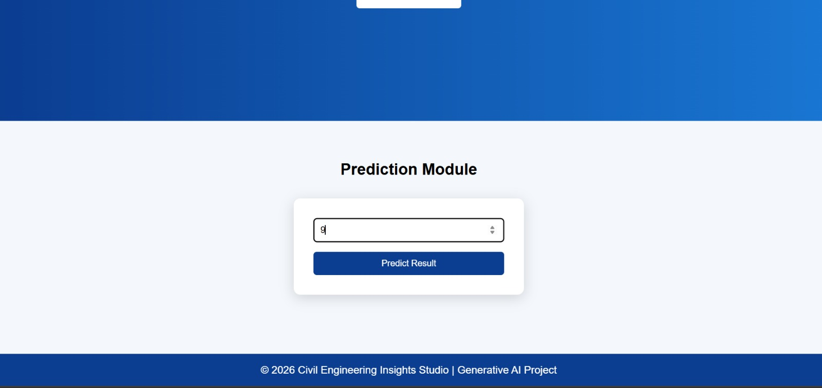
Prediction page

9. ADVANTAGES & DISADVANTAGES
Advantages
- Reduces manual work
- Accurate insights
- Easy visualization
- Time-saving
Disadvantages
- Depends on data quality
- Requires training for advanced features

10. CONCLUSION
Civil Engineering Insight Studio effectively demonstrates the integration of civil engineering principles with data analytics. The system enhances traditional engineering workflows and supports smarter decision-making in construction projects.

11. FUTURE SCOPE
- AI-based prediction models
- Mobile application
- Cloud deployment
- Real-time project monitoring

12. APPENDIX
Dataset:
Civil engineering insight studio dataset
Source code:
Available in project folder
Github Repositary:
https://github.com/Aruvai-Dakshayani/civil-engineering-insight-studio.git

Tools
Dataset:
Source Code: Available in project folder

Tools
Dataset:
Source Code: Available in project folder

